MINI PROJECT
CAR SALES DATA ANALYSIS AND VISUALIZATION USING PYTHON, POWER BI, AND TABLEAU
Framework for Data Visual Analytics

HARI PRASANNA S

241501064
ABSTRACT

This mini project, carried out for the subject Fundamentals of Data Visualization and Analytics (FDVA), analyses an Employee Attrition dataset using Python and Microsoft Power BI. The dataset, stored in a file named employee_attrition_cleaned.csv, contains 1,470 employee records with information such as age, gender, department, job role, education field, marital status, overtime, and attrition status. The project focuses on understanding employee turnover patterns and identifying workforce groups with higher attrition rates. Power BI was used to develop interactive dashboards featuring KPI cards for total employees, employees who left, attrition rate, and average age. Various visualizations, including donut charts, bar charts, column charts, stacked column charts, and line charts, were created to analyse attrition by department, age group, gender, job role, overtime, education field, and marital status. The dashboard showed that 237 employees left the organization, representing an overall attrition rate of approximately 16.12%. The analysis also highlighted differences in attrition across departments, job roles, and overtime categories. Interactive filters enable users to explore the data by different employee attributes and compare workforce trends. The project demonstrates how data preparation, visualization, and interactive dashboards can transform employee records into meaningful insights that support human resource management, employee retention strategies, and data-driven decision-making.

1. Data Preprocessing
The dataset (employee_attrition_cleaned.csv) contains 1,470 employee records and information related to employee demographics, job roles, departments, salary, overtime, and attrition status. Python with Pandas can be used to inspect and prepare the dataset for visualization in Microsoft Power BI.
1.1 Loading and inspecting the data
import pandas as pd

df = pd.read_csv("employee_attrition_cleaned.csv")

print(df.shape)
print(df.info())
print(df.head())
The dataset was loaded using Pandas, and its dimensions, column names, data types, and sample records were inspected to understand its structure and identify potential data quality issues.
1.2 Missing values and duplicates
print(df.isnull().sum())
print("Duplicate rows:", df.duplicated().sum())
Missing values were checked in all columns, and duplicate records were identified to ensure data consistency. Any missing values or duplicate records found during inspection should be handled appropriately before analysis.
1.3 Checking and correcting data types
print(df.dtypes)
The data types of the columns were examined to ensure that numerical attributes, such as Age, MonthlyIncome, and YearsAtCompany, were stored as numeric values, while categorical attributes, such as Department, Gender, JobRole, and Attrition, were stored in suitable formats. Any incorrect data types were corrected before visualization.
1.4 Standardising categorical values
categorical_cols = df.select_dtypes(
include="object"
).columns

for col in categorical_cols:
df[col] = df[col].apply(
lambda x: x.strip() if isinstance(x, str) else x
)
Text values were checked for unnecessary leading and trailing spaces to maintain consistency across categorical columns. Attributes such as Department, EducationField, Gender, JobRole, MaritalStatus, OverTime, and Attrition were reviewed to ensure that their categories could be analysed correctly in Power BI.
1.5 Creating the Age Group column
df["Age Group"] = pd.cut(
df["Age"],
bins=[0, 25, 35, 45, 55, float("inf")],
labels=[
"Under 25", "25-34", "35-44",
"45-54", "55+"
],
right=False
)
An additional categorical column, Age Group, was created to group employees into age ranges. This column supports the comparison of employee attrition across different age groups and makes the dashboard easier to interpret.
1.6 Exporting the prepared dataset
df.to_csv(
"employee_attrition_cleaned.csv",
index=False
)

print(df.shape)
The prepared dataset was saved as a CSV file for use in Microsoft Power BI. The resulting dataset was used to develop KPI cards and visualizations analysing employee attrition by department, age group, gender, job role, overtime, education field, and marital status. The interactive dashboard enables users to explore employee turnover patterns and identify workforce groups with comparatively higher attrition rates.
Note: The code above is a suggested preprocessing workflow. Confirm the actual missing-value counts, duplicate count, column count, and transformations performed in your project before including those results in the final report.

2. Data Visualization Using Python
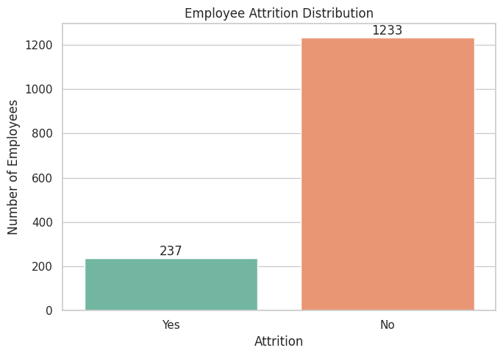
Figure 2.1: Employee Attrition Distribution
Result: Among total employees, 237 employees left the company, while 1,233 employees remained, indicating an attrition rate of approximately 16.1%.
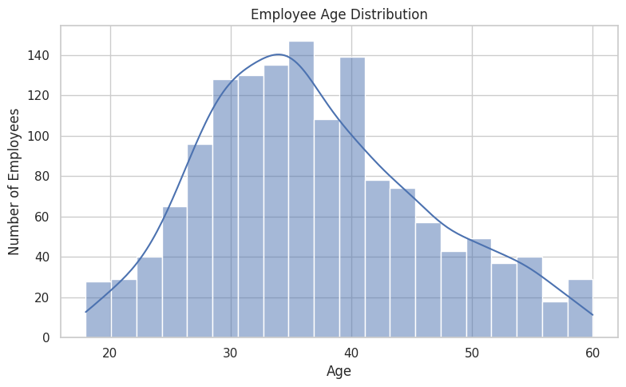
Figure 2.2: Employee Age Distribution
Result: Most employees are aged 28–40, with the highest frequency around 35 years.
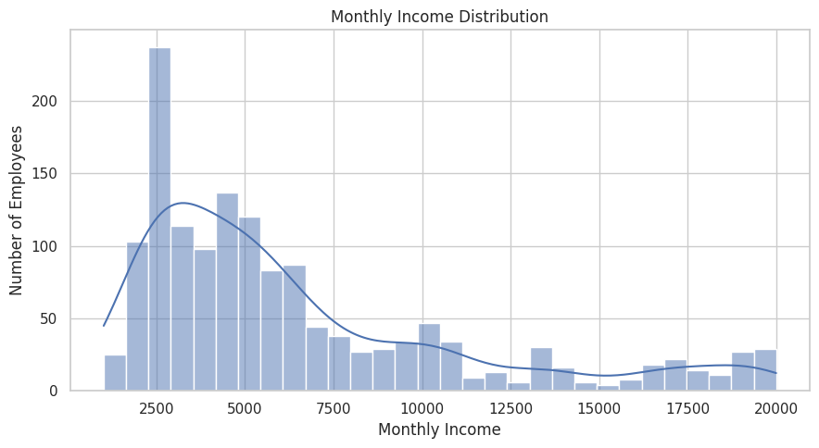
Figure 2.3: Monthly Income Distribution
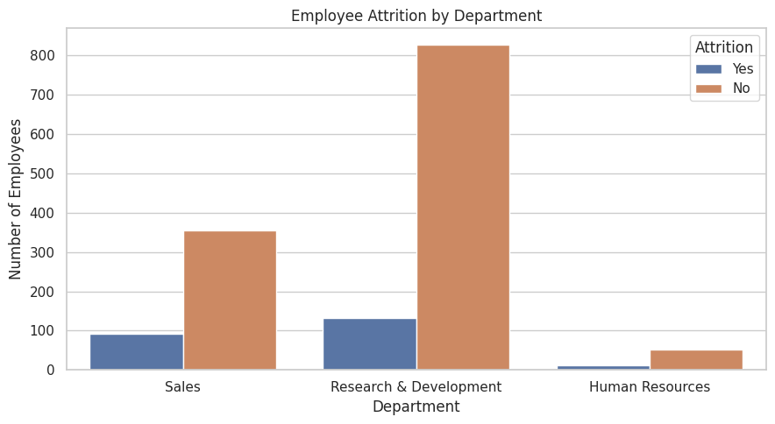
Result: Most employees earn between 2,000 and 6,000 per month, while fewer employees earn above 10,000.
Figure 2.4: Employee Attrition by Department
Result: Research & Development has the highest number of employees and attrition cases, followed by Sales and Human Resources.
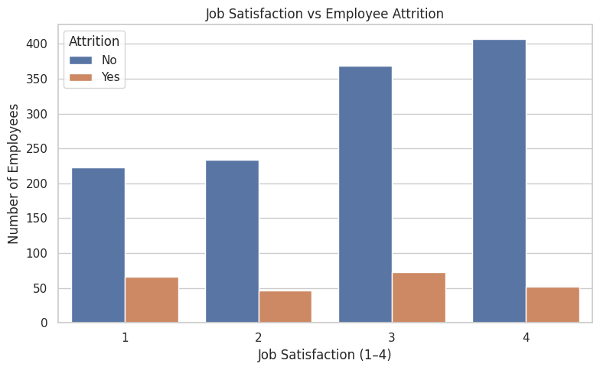
Figure 2.5: Job Satisfaction vs Employee Attrition
Result: Employees with higher job satisfaction generally show lower attrition, although employees at satisfaction level 3 also show notable attrition.

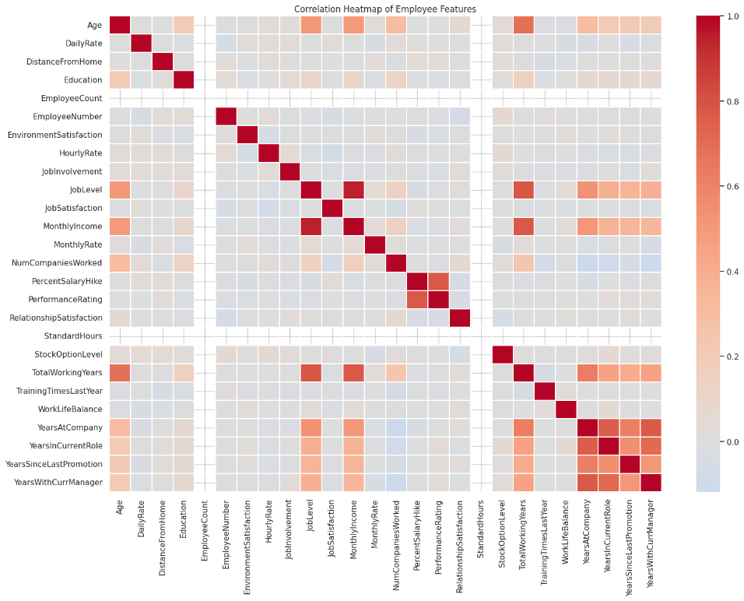
Figure 2.6: Correlation Heatmap of Employee Features

Result: The heatmap shows strong positive correlations among job level, monthly income, and years of experience, while most other features have weak correlations.

3. Power BI Dashboard
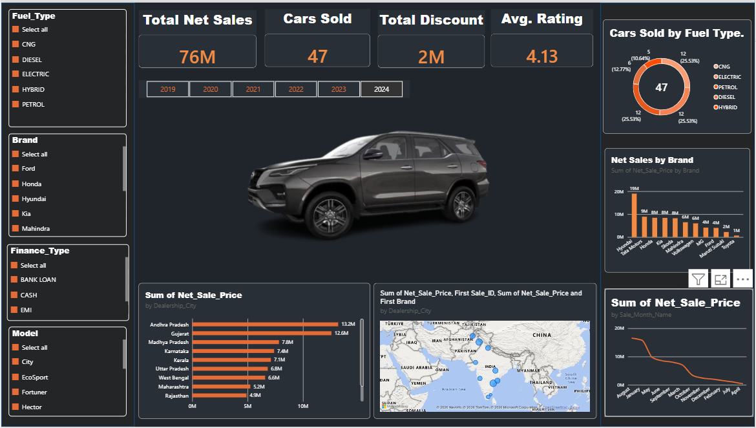
Figure 3.1: Car Sales Dashboard in Power BI
- KPI cards: Total Employees 1,470, Total Attrition 237, Average Monthly Income 7K and Average Job Satisfaction Score 3.
- Charts: Attrition by job role and distance from home, monthly income by education level and attrition, job satisfaction vs. attrition, promotion history vs. attrition, department-wise attrition and gender-wise attrition.
- Insights: A total of 237 employees left the company (16.1% attrition rate). Research & Development has the highest employee count (961), followed by Sales (446). Job satisfaction level 1 has the highest attrition rate (22.84%), while level 4 has the lowest (11.33%).
- Gender-wise analysis: 150 male employees and 87 female employees left the company.
- Note: The dashboard highlights employee attrition patterns across job roles, satisfaction levels, departments and gender to support HR decision-making.

4. Tableau Dashboard
Tableau was used to build the “Car Sales Performance & Business Insights Dashboard” from the same cleaned data.
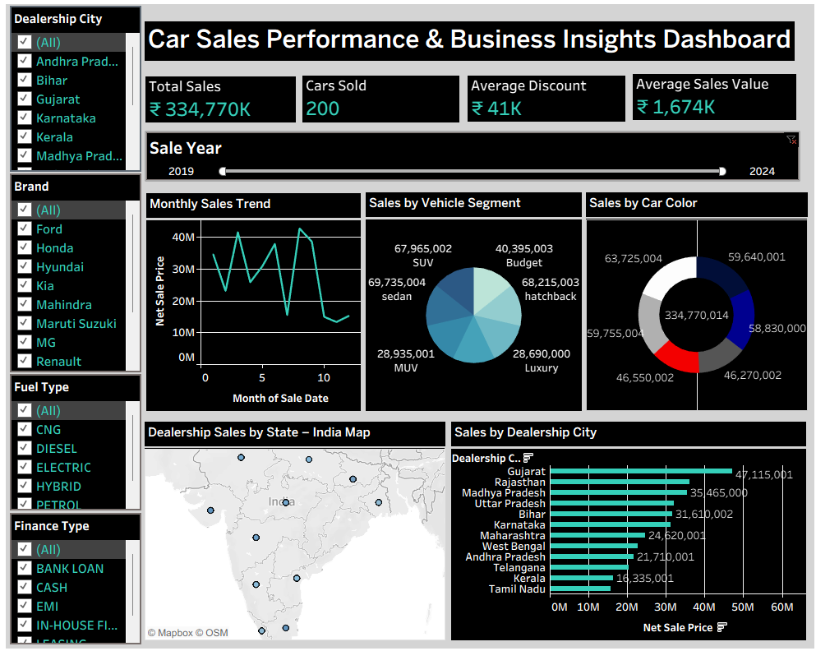

- KPIs: Total Employees 1,470, Attrition 237, Attrition Rate 16.12% and Average Age 37.
- Charts: Attrition by age group, attrition by years at company, department-wise attrition (donut chart) and average monthly income by income band (bar chart).
- Insights: Employees aged 26–35 have the highest attrition count (116). Employees with 1 year at the company show the highest attrition (59). Research & Development has the highest attrition (133), followed by Sales (92) and Human Resources (12). Average monthly income increases across the income bands.
- Note: The dashboard highlights employee attrition patterns by age, tenure, department and income to support HR retention decisions.

